|  |  |  |
| --- | --- | --- |
|  | **SRI KRISHNA COLLEGE OF TECHNOLOGY**  **An Autonomous Institution | Accredited by NAAC with 'A' Grade**  **Affiliated to Anna University | Approved by AICTE**  **KOVAIPUDUR, COIMBATORE 641042** |  |

#### TITLE of the Project

**A PROJECT REPORT**

***Submitted by***

#### SANJAY.K SHAHIN AHMED.F

**SACHIN.B SABARISH.B**

**SYED MOHAMMED ALI.S SANJAY KUMAR.V**

*in partial fulfilment for the award of the degree*

Of

#### BACHELOR OF ENGINEERING

**IN**

**ELECTRONICS AND COMMUNICATION**

**ENGINEERING**

**JANUARY 2023**



## CERTIFICATE

#### BONAFIDE CERTIFICATE

Certified that this project report **“CONTACT MANAGER”** is the Bonafide work of **SANJAY.K**, **SACHIN.B, SYED MOHAMMED ALIS.S, SHAHIN AHMED.F, SABARISH.B** and **SANJAY KUMAR.V** who carried out the project work under my supervision.

SIGNATURE SIGNATURE

XXXXX _____________

**HEAD OF THE DEPARTMENT SUPERVISOR**

Professor Assistant Professor

Department of ___________ Department of ____________

Sri Krishna College of Technology Sri Krishna College of Technology Kovaipudur Kovaipudur

Coimbatore-42. Coimbatore-42.



Certified that the candidates were examined by us in the Project Work viva- voce examination held on ............................... at Sri Krishna College of Technology, Coimbatore -641 042.

**INTERNAL EXAMINER EXTERNAL EXAMINER**



## ACKNOWLEDGEMENT

#### ACKNOWLEDGEMENT

First and foremost, we thank the **Almighty** for being our light and for showering his gracious blessings throughout the course of this project.

We are grateful to our beloved Dean-Academics **Dr. Manju P &** Dean-Administration **Dr R Ramesh Kumar** for their tireless and relentless support.

We extend our sincere thanks to our Head of the Department **­­­ECE** for his/her encouragement and inspiration.

We are greatly indebted to our Industry Mentor ________ & Project guide **_______** Assistant Professor, Department of ___________ for their valuable guidance and suggestions in all aspects that aided us to ameliorate our skills.

We are thankful to all those who have directly and indirectly extended their help to us in completing this project work successfully.

## ABSTRACT

### ABSTRACT

A contact manager project is a type of software application that allows users to store and manage contact information. It typically includes features such as contact search, contact management, contact group creation, and contact synchronization with other applications. The contact manager also typically includes features to share contacts with other users and to create and store notes on contacts. It can also include features to store notes on contacts and to import and export contact lists in different formats. Additionally, it may provide support for custom fields and other advanced features.

## LIST OF FIGURES

#### LIST OF FIGURES



|  |  |
| --- | --- |
| S.No | Figure Name |
|  |  |
|  |  |
|  |  |
|  |  |
|  |  |
|  |  |
|  |  |

## LIST OF TABLES

|  |  |  |
| --- | --- | --- |
| **TABLE NO.** | LIST OF TABLES | **TABLE DESCRIPTION** |
|  |  |  |
|  |  |  |
|  |  |  |
|  |  |  |



## LIST OF ABBREVIATIONS

#### LIST OF ABBREVIATIONS

|  |  |
| --- | --- |
| **ABBREVIATIVE** | ***ABBREVIATION*** |
| CRM | *Customer Relationship Management* |
| CMP | Contact Management Platform |
| CM | Contact Manager |



***TABLE OF CONTENTS***

|  |  |  |
| --- | --- | --- |
| **CHAPTER**  **N.O** | **TABLE**  **OF**  **CONTENTS** | **TITTLE**  **OF**  **PAGE** |
| 1 | INTRODUCTION |  |
| 2 | LITERATURE SURVEY |  |
| 3 | PROPOSED SYSTEM |  |
| 4 | METHODOLOGY DETAILS |  |
| 5 | IMPLEMENTATION AND  RESULT |  |
| 6 | CONCLUSION AND FUTURE SCOPE |  |

## INTRODUCTION

### CHAPTER 1 INTRODUCTION

The Contact Manager Project is an intuitive and powerful contact management system designed to help users easily store, manage, and search contact information. This project provides users with a user-friendly interface for adding, updating, and deleting contacts, as well as for creating and managing contact groups. Additionally, users can easily send messages to individual contacts or groups of contacts. This project is ideal for anyone looking for an efficient way to organize and access their contacts.

* 1. **PROBLEM DEFINITION**

The Contact Manager Project aims to provide users with an efficient and user-friendly way to store, manage, and search contact information. The project will enable users to easily add, delete, and update contacts, as well as create and manage contact groups. Additionally, users will be able to send messages to individual contacts or groups of contacts. This project will provide an efficient solution for organizing and accessing contact information, making it easier for users to stay connected with their contacts.

#### OVERVIEW

Our main focus is to develop a far better security system by using fingerprint-based ATMs. Biometrics may be a technology that helps to form your data extremely securely, unique to all or any of the users by way of their personal physical characteristics. Biometric information is employed to spot the people perfectly by using their fingerprint, face, speech, iris, handwriting, or hand geometry then on. Tokens like mag tape cards, smart cards and physical keys, are often stolen, lost, replicated, or left behind; passwords are often shared, forgotten, hacked or accidentally observed by a third party. There are mainly two key functions offered by a biometric system. one of those techniques is identification and therefore the other is verification. Fingerprint technology is very accepted nowadays and may be a matured biometric technology and is the easiest to develop and for a complicated level of security at the fingertips. it's easy to implement and it might take minimum time and energy to get one‘s fingerprint registered with a fingerprint identification device. Thus, fingerprint recognition is taken

2

into account between the minimum intrusive of all biometric verification methods. During ancient time‘s officials used thumbprints to seal documents thousands of years back, and law agencies have been using fingerprint identification since the late 1800s.We here carry an equivalent technology on digital platforms. Although fingerprint images are initially captured, the pictures aren't kept anywhere within the system. Instead, the fingerprints are converted to templates from the first fingerprints. Not recreate it. Hence, no misusing of the system is possible [1].

Nowadays, the self-service banking system has wide popularization with the characteristic offering excellent 24 hours‘ service for patrons. Using the ATM (Automatic Teller Machine) which might provide customers with convenient banknote trading is extremely common. However, the financial crime case has risen repeatedly in recent years, Lot of criminals‘ tamper with the ATM terminal and steal the user's mastercard and password by illegal means. Once User‘s credit card is lost and therefore the password stolen, the criminal withdraws and takes advantage of the shortest time, which can bring enormous financial losses to the customer. The way to keep it up is the valid identity to the customer as it becomes the main target in Current financial circle. Traditional ATM systems authenticate generally by using the master card and password, the tactic has some defects. employing a master card and password alone cannot really verify the client's identity exactly. within the past few years, the algorithms that are used have fingerprint recognition continuously updated and sending the four-digit code by the controller which has offered the new verification means for us, the first password authentication method is combined with the biometric authentication technology verify the clients' identity better and achieve the aim that use of ATM Machines improve the security effectively [2].

#### OBJECTIVES

The ideology is to propose validation and confirmation measures on the current, ATM machine and to make a fruitful and secure exchange. The fundamental goal of this undertaking is to give a unique mark as an approved character and to plan a safer ATM framework. In this, the ATM machine fills in as when the client places his/her finger on the biometric scanner of the ATM and if the finger coordinate is discovered it will show the name of the client on the ATM machine. If by chance, that Fingerprint coordinate is not



## LITERATURE SURVEY

### CHAPTER 3 LITERATURE SURVEY

.



# PROPOSED SYSTEM

### CHAPTER 4 PROPOSED SYSTEM

The proposed system to increase safety and security by introducing a fingerprint system. The advantage of finger-scan technology is accuracy. By using the fingerprint system many disadvantages are rapidly reduced. They do not have the need to carry an ATM card in your wallet and no chance of loss card, CARD can be stolen, password can be shared or, hacking all customers are satisfied by our system because of quick and better service.

Moreover, initially Fingerprint is converted into string values that are stored in the EC2 database. Every user's fingerprint is stored as a string which means every string is unique. All the strings are stored in a vast cloud memory, when a user withdraws his money, he places his finger print, then that unique string is being searched in the cloud and the authentication process takes place.

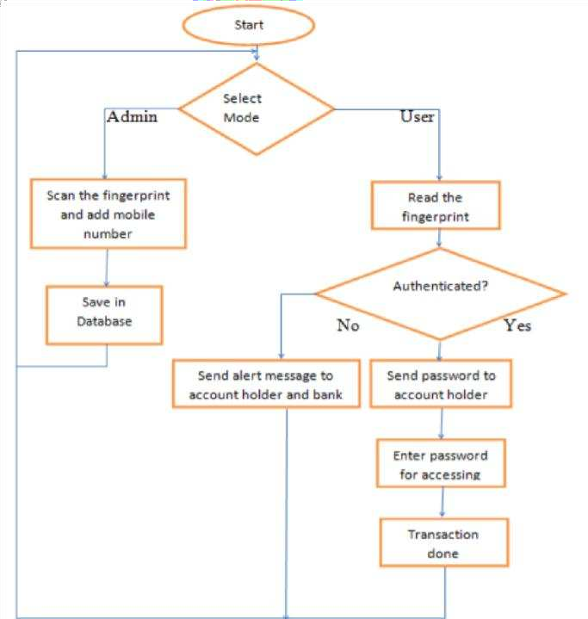

#### Fig.4.1. Flowchart for ATM fingerprint

#### ADVANTAGES

* + - Fingerprint based ATM System is more secure than ATM card.
    - User can make transaction using his fingerprint any place and at any

time, he need not have to carry an ATM card.

* + - User can transfer money to various accounts by mentioning account

number in case of emergency.

* + - The system can be used in various Banks.
    - Low educated people can access it easily.
    - When our ATM card is misplaced then no one uses or access it. It

automatically blocks.

* + - No one can hack the pin code. The hackers can easily guess the 4-

digit pin code



***METHODOLOGY DETAILS***

### CHAPTER 5

**METHODOLOGY DETAILS**

Unique mark confirmation is to check the realness of one individual by his finger impression and PIN code and Fingerprint distinguishing proof is by coordinating the data of the client, for example, pin code and unique mark coordinating. Essentially, we can clarify total Fingerprint based ATM framework in two stages:

* Enrolment Phase
* Authentication phase

#### Enrolment phase:

In the robust fingerprint application, up to 3-4 fingers should be enrolled. This enables the system to set a high security threshold and still be able to cope with everyday real-life issues like skewed finger placement dirty, wet dry, cut or worn fingers. The biometric reference data is collected for enrollment and stored in a database or in portable data carrier such that Enrolment is crucial because the once recorded reference data will normally be used over the active lifetime of the user or his/her biometric hardware device.

#### Multiple Finger enrolment:

It is strongly recommended to enrol more than one finger. During daily life injuries can happen that turn a registered fingerprint currently unusable while minor cuts do not affect a robust sized sensor system.

#### Authentication Phase:

In this phase users can make transactions by using their fingers. User can place a finger on the Biometric scanner and the user's finger

scan can be matched through a database, where all authenticated user‘s fingerprints are stored. If User wants to do a transaction, they simply place their finger on a biometric scanner and get their money in a few seconds. If a user's fingerprint cannot match by database due to some accidental cuts on their fingers, then they can use their other fingers and we will also provide a 4-pin code option, users can also use this option with their conveniences. Feature extraction: The feature extraction process from a fingerprint image is generally categorized into three levels. Feature can be used to categorize into major pattern types such as loop or whorl.

#### EQUIPMENT AND METHODOLOGY Fingerprint sensor:

For thedevelopment of the ATM,R307 Fingerprint Module consists of optical fingerprint sensor, high-speed DSP processor, high- performance fingerprint alignment algorithm, high-capacity FLASH chips and other hardware and software‘s compositions, stable performances, simple structures, with fingerprint entry, image processing, fingerprint matching, search and template storage and other functions

**Raspberry Pi 3RPig:**

low cost, small credit-card sized computer. RPi3 is faster than Arduino

**Cloud server and Fingerprint processing:**

Host server is AWS EC2. Date, time, message status, ID, sensor value and also Fingerprint is converted into string value and stored in the EC2 database. Every user's fingerprint is stored as a string. Which means every string is unique? All the strings are stored in a vast cloud memory, when a user withdraws his money, he places his finger print, then that unique string is being searched in the cloud and the authentication process takes place.

**Software Role:**

21

The authentication process is done by a few simple steps for all users. First the basic details which comprises State, district and branch are being selected to make it fast and easy for the software to search the desired string (to verify the fingerprint). Then the verification takes place within a few seconds and the money can be withdrawn.

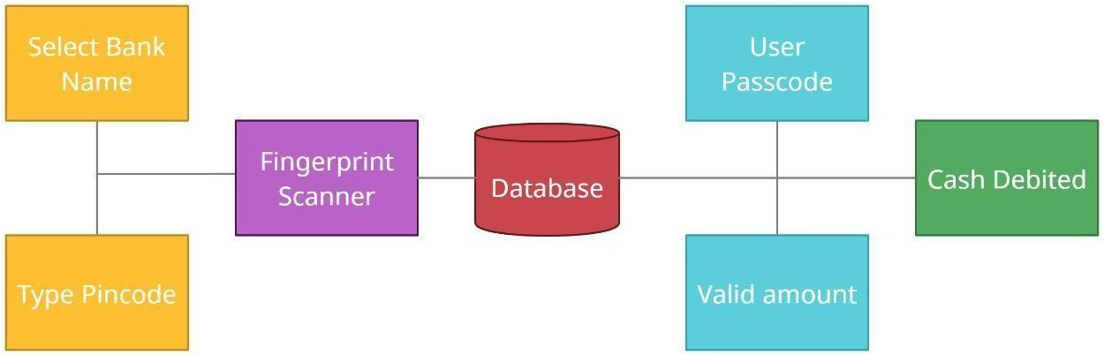

#### Fig.5.1. Diagram for Fingerprint based ATM



***IMPLEMENTATION AND RESULT***

**CHAPTER 6 IMPLEMENTATION AND RESULT**

* 1. **FINGERPRINT SYSTEM WELCOME MODULE**
  2. **SURVEY OF FINGERPRINT WITH OTHER BIO**

#### ALGORITHM

#### SAMPLE CODE

#### PASSWORD CHECK

## CONCLUSION AND FUTURE SCOPE

#### CHAPTER 7

**CONCLUSION AND FUTURE SCOPE**

#### 7.1 FUTURE SCOPE

#### REFERENCES